Title: Evidence to Support Environmental and Contextual Modifications to Improve Participation in Community Events for Children with Disabilities

Authors: Alexis Howell, OTS, Ryan James, OTS, Teri Priest, OTS, Emily Sandy, OTS, Meghan Williams, OTS,
Faculty Mentor(s): Pamalyn Kearney, EdD, OTR/L, Mallory Rosche, MHS, OTR/L
Presented in Partial Fulfillment of the Master of Health Sciences in Occupational Therapy degree at Augusta University

Objectives of Presentation: At the conclusion of this poster, attendees will:
1. Identify 2 contextual and environmental barriers that inhibit the participation of children with disabilities as identified through a scoping review of the peer-reviewed literature.
2. Describe at least 1 benefit of community participation for children with disabilities, as identified through a scoping review of the peer-reviewed literature.
Clinical/Research Question: What evidence is available to support modifications to environments and contexts to improve participation in community events for children with disabilities under the age of 18?
Methods:
- A scoping literature review was conducted of literature between 2012 and 2020 using Arksey & O’Malley’s protocol⁷.
- We searched PubMed, CINAHL, and EBSCOhost (last search date: February 17, 2021).
- Inclusion Criteria: Articles that addressed any mental, physical, developmental disability, community-based setting, or dealing with social participation in the school setting. Articles that addressed child participation in the community to any degree as an outcome.
- Exclusion: Not written in English, > 50% of participants over 18 years old, modifications made in the school environment strictly for academics.
- We identified 199 articles via database searches and screened 156 by title/abstract. From these, 57 articles were evaluated for meeting inclusion/exclusion criteria by 2 reviewers, and 26 articles were included in the study.
Results:
- 26 articles were included in the study 14 descriptive (54%), 5 correlational (19%), 7 experimental (27%).
- Three out of the seven experimental studies discussed the Pathways and Resources for Engagement and Participation (PREP) which is further discussed in the conclusion.

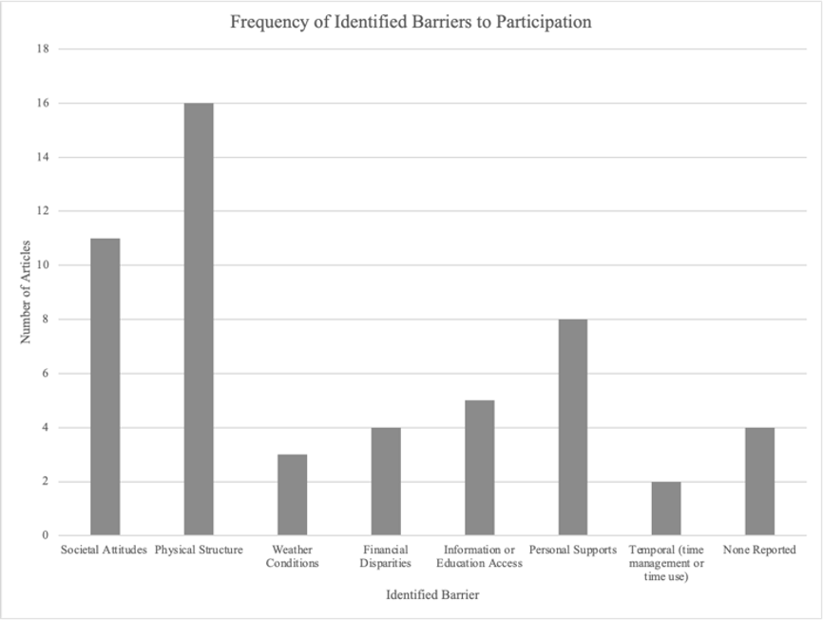

Implications:
- Practitioners and educators should consider:
- Developing interventions that address the physical environment of community settings
- Providing resources to parents that address the physical environment of community settings
- Researchers should consider:
- Completing a systematic review of intervention studies for community participation
- Conducting further research on this topic
References
(1) King, G., Law, M., King, S., Rosenbaum, P., Kertoy, M. K., & Young, N. L. (2003). A conceptual model of the factors affecting the recreation and leisure participation of children with disabilities. [Abstract]. Physical & Occupational Therapy in Pediatrics, 23(1), 63–90.
(2) Bedell, G., Coster, W., Law, M., Liljenquist, K., Kao, Y. C., Teplicky, R., Anaby, D., & Khetani, M. A. (2013). Community participation, supports, and barriers of school-age children with and without disabilities. Archives of Physical Medicine and Rehabilitation, 94(2), 315–323.
(3) Arakelyan, S., Maciver, D., Rush, R., O'Hare, A., & Forsyth, K. (2020). Community-based participation of children with and without disabilities. Developmental Medicine and Child Neurology, 62(4), 445–453. https://doi.org/10.1111/dmcn.14402
(4) United Nations General Assembly (2007, January 24), Convention on the Rights of Persons with Disabilities: resolution / adopted by the General Assembly. https://www.un.org/disabilities/documents/convention/convoptprot-e.pdf
(5) Law, M., Petrenchik, T., King, G., & Hurley, P. (2007). Perceived environmental barriers to recreational, community, and school participation for children and youth with physical disabilities. Physical Medicine and Rehabilitation, 88(12), 1636-1642. https://doi.org/10.1111/j.1365-2788.2008.01128.x.
(6) Arksey, H., & O’Malley, L. (2005). Scoping studies: Towards a methodological framework. International Journal of Social Research Methodology, 8, 19–32. http://dx.doi.org/10.1080/1364557032000119616
(7) Anaby, D., Vrotsou, K., Kroksmark, U., & Ellegård, K. (2020). Changes in participation patterns of youth with physical disabilities following the Pathways and Resources for Engagement and Participation intervention: A time-geography approach. Scandinavian Journal of Occupational Therapy, 27(5), 364-372. https://doi.org/10.1080/11038128.2018.1554088

Contact Information:
Alexis Howell: alexishowell56@gmail.com
Teri Priest: teri1526@gmail.com

